**Extract Transform Load Pipeline**

*Database se data layenge.*

*Then usme 1 Transformation hoga then usko uthake hum Dusre Database mai store karenge.*

*Database jo hoga vo AWS pe hoga usme kuch transformation apply karenge then ush transform database ko vapas AWS pe Load karenge.*

**Why we doing this?**

**Case Study**

**1 startup hai jo Dreameleven type hai but vo prediction karta haii**

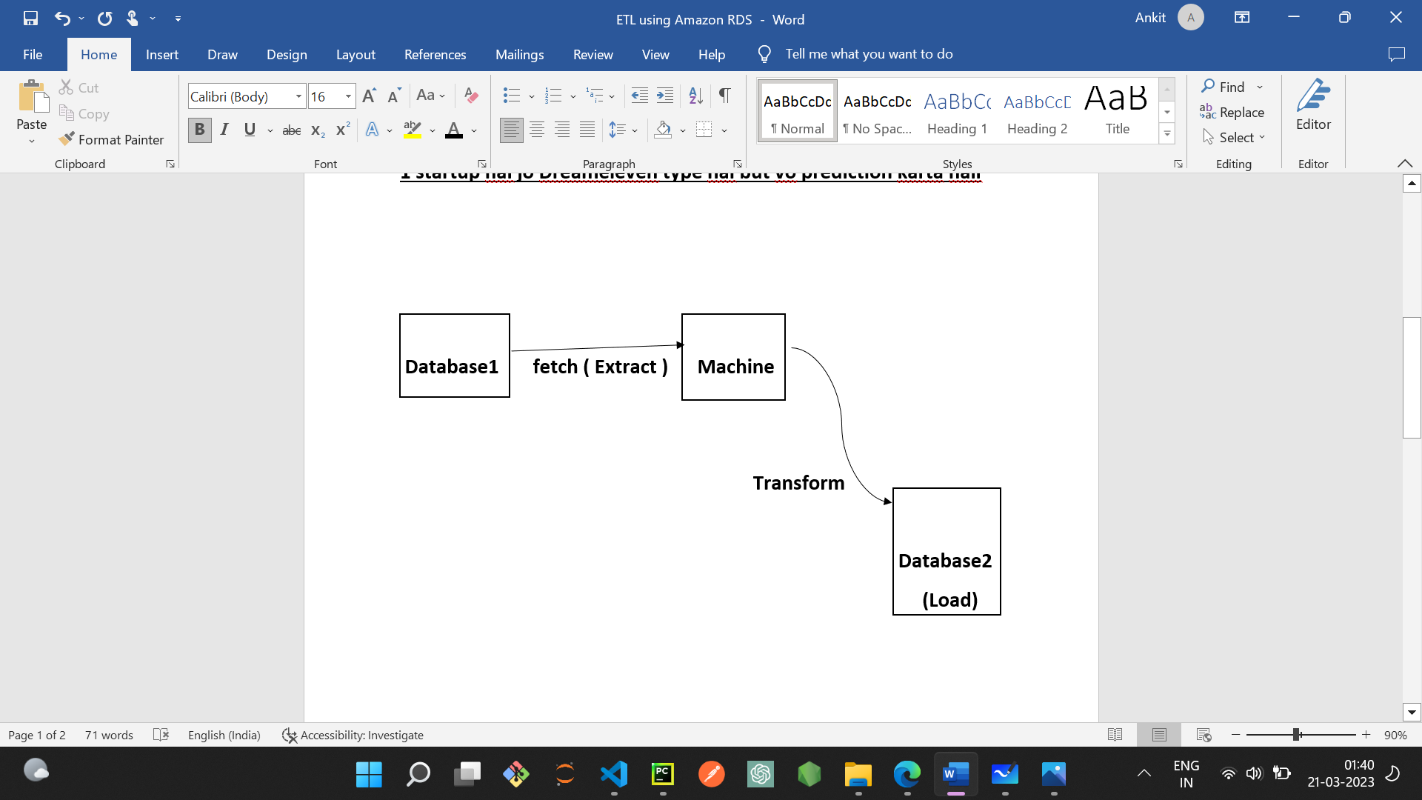

Extract Transform Load Pipeline

**OLTP & OLAP**

***OLTP (****Online Transactional Processing****) isko hie industry mai database bollte hai***

*Online Transactional Processing Database Kindoff Normal Database* ***it is running Database***

*If Aapke Team mai koi Analytics ka banda hai*

*Generally bola jaata hai ki ushe OLTP pe kaam nahi karna chaye, because it is live database.*

*So much solution better is*

*OLTP se hum OLAP banate hai*

***OLAP (****Online Analytical Processing****)-> OLAP ko industry mai Date Warehouse bolte hai.***

*If koi Analysis krta hai then vo OLAP pe kaam krte hai*

*OLAP*

*OLAP is a separate database basically OLTP ka copy. Aur bhi kuch differences hote hai iske sath.*

*Setup*

*Step 1-> AWS se leeke aayenge database*

*Step2 -> Transformation Apply krenge*

*Step3 -> Naya Database Banayenge on AWS hie*

*Step4 -> Transform database jo hai ushe upload karenge*